Business Rules Management System (BRMS)
BRMS maintains rules that are executed in a production rule system but also maintained in a repository with a user interface suitable for business users to create, read, update and delete them.

The main benefits of a BRMS are:
- Reduced or removed reliance on IT departments for changes in live systems. This means that to change a business rule, you don't need to change any code. It is all done through a GUI.
- Increased control over implemented business logic, for compliance and better business management.

Drools on first glance can be quite daunting, it is made up of :
- Drools Expert (rule engine)
Being a developer this is where I will begin, the actual rules and implementation of them.

The other parts I'll get to later are:
- Drools Guvnor (BRMS/BPMS)
- Drools Flow (process/workflow)
- Drools Fusion (event processing/temporal reasoning)
- Drools Planner (automated planning)

What is Rule engine?
Very simply, it is a place in which we can evaluate our business rules

The core of a Rules System is an Inference Engine that matches data (also called Facts) against Rules to infer conclusions which result in actions. This process of matching the new or existing facts against Rules is called Pattern Matching. Rule Systems make use of highly efficient multi-object multi-pattern matching algorithms. The precise algorithm varies from provider to provider.

The Rules are stored in what is called the Production Memory and the Facts that the Inference Engine matches against in what is called the Working Memory. Facts are asserted into the Working Memory where they may then be modified or retracted.

When Facts match a Rule, the rule is said to be activated and an Activation for that Rule is created.

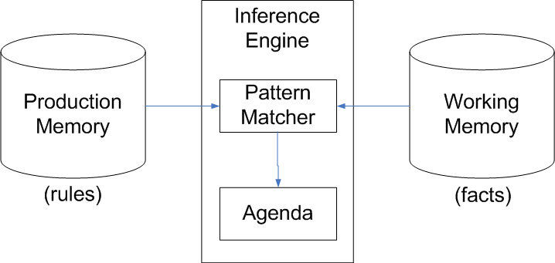
The execution of an activated rule can update working memory. This can happen if rules action asserts new Facts or modifies or retracts existing Facts. Updates to working memory can create new Activations or cancel previously created Activations that have not yet been executed. The rule system ensures truthfulness - a rule's action is executed only if the inference is true. This is called Truth Maintenance.

A system with a large number of rules and facts may result in many rules being activated for the same fact assertion. These activated rules are said to be in conflict. The Agenda manages the execution order of these conflicting rules using some Conflict Resolution strategy.

You should seriously consider rule engine when the following conditions apply.

- You have complex business logic
- Business logic changes often
- You want to provide visibility of the business logic to a wider audience, including business analysts
- You want to empower business folks with owning and managing business logic and rules

Benefits of drools
Here are a couple of points that explain why rule engines are better than most computer systems:

- Rule engines allow you to say "what to do", not "how to do it". This means that you can focus on what you know to be true, and allow the machine do the heavy lifting of figuring out the consequences of all of these combined truths'.

- Logic and data separation: You probably already have a database to store information. It's a good place for data, but a bad home for your business rules. Having a rule engine gives your rules a natural home where you can manage your (entire) business knowledge properly.

- Speed and scalability: The way rule engines work (based on the Rete algorithm, if you're interested) has been mathematically proven to be faster and more scalable than most traditional hand coded 'if…then' solutions.

- Powerful tools: For developers, as well as for business analysts, tools provide easy ways to edit and manage rules. More importantly, they give immediate feedback — no more slogging through 10 web screens to reproduce a 'bug' in the business logic.

- Auditing: Rule systems provide an explanation facility allowing you to audit how and why a particular decision was made.

AI Talk

Let’s explore a little the AI background of rule engines. In AI speak a rule engine is a Forward Chaining Expert System. A forward chaining expert system reasons bottom up based on facts to arrive at some conclusions. In contrast, a Backward Chaining Expert System reasons top down from a hypothesis and tries to establish if the hypothesis id supported by the given facts. The following table is a side by side comparison of forward chaining and backward chaining.

Forward chaining | Backward chaining
Bottom up reasoning driven by facts | Top down global driven reasoning
Works forward to find inference from facts | Works backwards to find facts supporting hypothesis
Useful for planning and controlling | Useful for diagnosis

When you visit your doctor, what goes on in the doctor’s mind, in my opinion is little bit of forward chaining and backward chaining. Based on the symptoms you have provided, the doctor does forward chaining reasoning to arrive at some hypothesis.

Then as you may have observed, as your conversation with doctor continues, the doctor tries to elicit more facts by asking you about specific additional symptoms. What’s going on at this stage is that the doctor is doing backward chaining to prove the validity of the initial hypothesis by checking with additional facts.

How can you write rules?
- You can use the Business Rules Management System(BRMS)from Drools, which is called Guvnor
- You could write the rules via a simple text editor such as Notepad
- You can write rules in Microsoft Excel or any spreadsheet that can output Excel-like spreadsheets
- Use the Drools IDE, which is based on Eclipse.

Inside a Rule Engine

For those unfamiliar with rule engine, it’s natural to ask the question “what’s inside a rule engine?”. At it’s heart, a rule engine contains the following

- A set of facts
- A set of rules

Fact: A fact is essentially a piece of data that is matched with the left hand conditional part of a rule. With Drools, the facts will a be set of Java objects. A rule is essentially like an if statement in a programming language.

Functionality of rule engine

The rule engine execution logic can be summarized as follows. This is the general behavior of a rule engine. The exact behavior could vary depending on the implementation.

When invoking the rule engine, the client application specifies the rules to use and feeds the data to be used as facts. All the facts resided in so called working memory inside the rule engine

- The rule engine goes through all the rules
- It tries to match the match the left hand condition with the facts in working memory
- Any rule that matches goes into what’s called an activation queue
- It’s executes the rules in the activation queue one at a time.
- If the rule action modifies any fact in the working memory or adds new facts , the rule engine goes back to step 1
- The rule engine quits, when there is not more rule left in the activation queue for execution

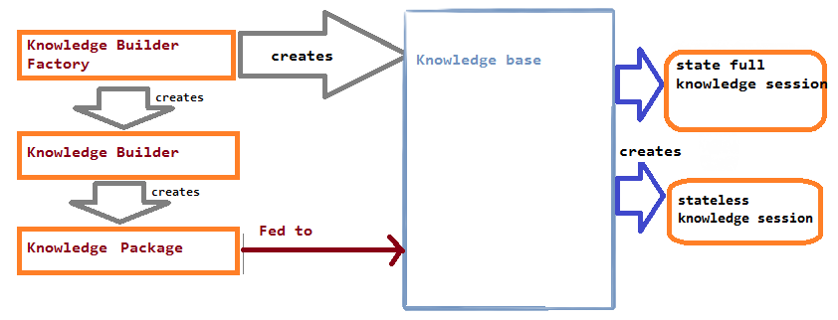
Note One key point to note is that the sequence in which the rules are executed is not deterministic. In other words, your application can not rely on the sequence in which rules are executed by the rule engine.

Many rule engines including Drools, provide some control over the rule execution order. This is achieved by assigning priority to rules, which essentially sorts the rules inside the activation queue.

Rules may described in many syntaxes, e.g., XML, proprietary syntax and associated grammar, spreadsheet. Some products provide visual GUI tools for rule creation and storage.

JBoss supports business rules implementation using three techniques:

- Decision Tables
- Writing DRL file
- Defining business flow using rules flow rf file

General steps needed to use Drools in your application
Here is an overview of how to use Drools in your application:

- Create a POJO (Plain Old Java Object) domain model complete with attributes. It should model all the concepts needed by your rules
- Author your rules using your domain model in your desired format. The rules be written in the drools rule language, a decision table, or a domain specific language
- Build a KnowledgeBase using one or more rule resources.
- Create a KnowledgeSession from the KnowledgeBase
- Insert populated POJOs into the KnowledgeSession
- Run the rules which then modify the appropriate POJOs
- Use the modified POJOs in your application

Knowledge on StatefulKnowledgeSession

names might be a bit misleading at first, because both sessions maintain state. The difference is that a stateful session also maintains its state between session invocations (calls to the fireAllRules method). This is useful when we need to call rules multiple times over a period of time while making iterative changes to its state.

Another use case is if we need to execute the same set of rules over the same facts that don't change very often over time. It would be a waste of computer resources to insert all facts over and over again. Instead, we should use a stateful session and tell it about the facts that have been changed since the last execution.

The disadvantages are that working with this session is more complex, because we have to take into account its state unlike in a stateless session, where a new state is formed with each session invocation. A stateful session needs to be destroyed when we finish working with it. Only then can the garbage collector reclaim the resources it holdDrools supports two kinds of knowledge sessions for executing rules: stateful and stateless. The

Domain Specific Language (DSL) :-

Every profession has its own language, or what is called a jargon. This jargon could be more likely to be in English. So that every one can easily understand.

Doctor to nurse:
Give me sterilised scalpel number 4, spreaders — the patient's cardioangiogram is showing traces of acute defibrillation.

In plain English, this means:
Give me a knife now, this guy's having a heart attack.

One of the reasons why each profession, or domain, has its own specific language (or DSL) is that it conveys information much more precisely and concisely. Expressing rules in a format friendly to Non-technical users is to use a DSL. It acts as a translator. It defines how to translate sentences from the problem-specific terminology into rules. The translation process is defined in a .dsl file. The sentences themselves are stored in a .dslr file. The result of this process must be a valid .drl file.

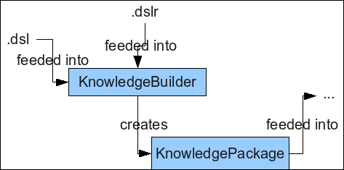
The KnowledgeBuilder object acts as the translator. It takes the .dslr file, and based on the .dsl file, it creates the DRL. This DRL is then used as normal

Link for decision table implementation
http://technicalmumbojumbo.wordpress.com/2009/03/28/jboss-drools-decision-tables/

Link for drl file implementation
http://technicalmumbojumbo.wordpress.com/2009/05/20/jboss-drools-defining-business-rules/

